Staff Uniforms Order

STAFF MEMBER:
ORGANISATION:
DATE: |  | EMPLOYEE NO.

Style No. | Description | Size | Qty
Alterations
Jacket
Trouser
Shirt

………………………………………………………………………………………………
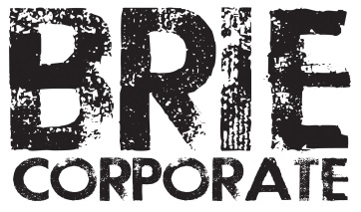

BRIE Corporate Pty Ltd
PO Box 865, Albury NSW 2640
02 6066 0151
orders@briecorporate.com.au
www.briecorporate.com.au

